The Role of Hydration in the Model Biological Membranes
N. Kučerka

Frank Laboratory of Neutron Physics, Joint Institute for Nuclear Research in Dubna, Russia
and Faculty of Pharmacy, Comenius University in Bratislava, Slovakia
kucerka@nf.jinr.ru
Abstract. Throughout the biological world cell membranes are crucial to life, with lipids being one of their major components. Besides proteins playing an active role in carrying out the various functions that take place in a biological membrane, much attention has recently focused on the importance of lipids in membrane function. Various experimental data reveal intriguing peculiarities in their structural properties. Interestingly, one of the common alterations that is observed at the membrane-water interface underlines the important role of membrane hydration properties. A plausible mechanism of action in the case of many membrane additives seems to be in shifting the water encroachment the way that bilayers absorb more or less water molecules - one of the smallest and often neglected biomolecule. The difference in water interactions with different lipids has been noted at the interface and up to the bilayer center, the ion depending interplay between lipid-water and ion-water hydrations has been shown, and the anaesthetic effect also appears to link tightly to hydration, to discuss but a few examples. Although a complete understanding of the physicochemical processes taking place in biomembranes is not established fully, the understanding of lipid bilayer structural changes as a result of different properties of environment outside and/or inside the membrane provides a foundation for better insights into the structure-function relationships that most certainly take place in complex biomembrane systems.

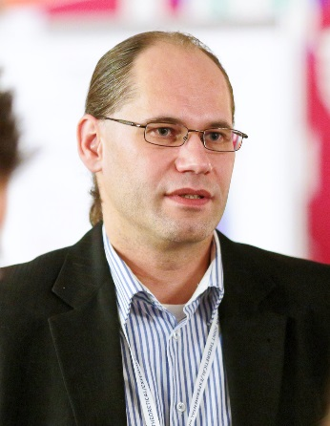
Norbert Kučerka, Ph.D. received his M.S. degree from Comenius University in Bratislava, Slovakia in 1999 and Ph.D. degree in the field membrane biophysics for his research utilizing the small angle neutron scattering in 2003. He was a post-doctoral fellow with John Nagle at Carnegie Mellon University in Pittsburgh, USA (2003-2006), and with John Katsaras at the Canadian Neutron Beam Centre in Chalk River, Canada (2006-2008). He continued his research using neutron diffraction at the CNBC as a National Research Council research officer till 2014, when he moved to Joined Institute for Nuclear Research in Dubna, Russia. In Dubna he serves as a deputy director of Frank Laboratory of Neutron Physics, continuing at the same time his research of model biological membranes using the scattering of neutrons and X-rays. Presently, his work is focused on the structure and interactions in membranes playing a role in the Alzheimer’s disease.

