Magnetically responsive (nano)textile: Preparation and application
Ivo Safarik
Department of Nanobiotechnology, Biology Centre, ISB, Academy of Sciences, Na Sadkach 7, 370 05 Ceske Budejovice, Czech Republic.
ivosaf@yahoo.com
Abstract. Currently there is an increased interest in the study of smart multi-functional (nano)textiles that are sensitive to environmental changes and respond to external fields; such (nano)textile can be used for a large number of potential technological applications. Of particular interest is the use of magnetic materials in combination with (nano)textile materials. Different types of magnetic nano- and micromaterials including magnetite, maghemite or ferrite particles, or magnetic iron wires can be used for (nano)textile modification. Magnetically responsive (nano)textile can be efficiently used for potential medical applications (magnetic hyperthermia for the treatment of cancer cells, scaffolds for the proliferation of osteoblasts, drug delivery, magnetic resonance visualization of surgical textile implants or biosensing), biotechnology (prevention of fungal biofilms development on functionalized textile, antibacterial properties), construction of magnet-induced temporary superhydrophobic textile coatings, shielding of electromagnetic field or as magnetic carriers for the immobilization of biologically active compounds, affinity ligands, microbial cells and (nano)particles. Magnetically modified (nano)textile also exhibits peroxidase-like activity. Recently a new analytical procedure called Magnetic textile solid phase extraction (MTSPE) has been developed and used for the preconcentration of target organic and inorganic analytes. It can be expected that magnetically responsive (nano)textile will find other interesting applications in the near future.

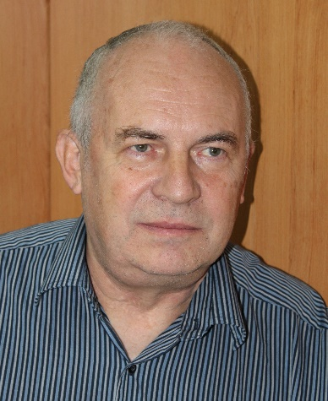
Ivo Safarik, Prof., PhD., DSc., received his Ing. degree from Institute of Chemical Technology in Prague in 1978. In 1984, he was awarded his PhD. degree in biochemistry and in 1993 he became Associate Professor in biochemistry at the same institution. In 2008 he became Full Professor in biochemistry at Palacky University in Olomouc. DSc. degree in biochemistry was awarded by the Czech Academy of Sciences in 2001. His research interest is mainly focused on the development and characterization of new types of magnetically responsive (bio)materials and their use in various areas of biochemistry, microbiology, algology, (bio)analytical chemistry, polymer chemistry, medicine, biotechnology and environmental technology.

