Fast Volumetric Bioimaging Based on Temporal Focusing Widefield Multiphoton Microscopy
Shean-Jen Chen
College of Photonics, National Chiao Tung University, 711 Tainan, Taiwan.
sheanjen@nctu.edu.tw
Abstract. In this talk, first I will show that a developed temporal focusing-based multiphoton excitation microscope (TFMPEM) has a digital micromirror device (DMD) which is adopted not only as a blazed grating for light spatial dispersion but also for patterned illumination simultaneously. The TFMPEM has been extended to implement spatially modulated and digital holographic illumination to increase the beam coverage at the back-focal aperture of the objective lens. The axial excitation confinement (AEC) of TFMPEM can be condensed from 3.0 μm to 1.5 μm. By using the TFMPEM with HiLo technique, reconstructed deep-biotissue images according to the condensed AEC structured illumination are shown obviously superior in contrast and better scattering suppression. Then, I will show that temporal focusing-based multiphoton illumination (TFMPI) has the advantage of widefield multiphoton excitation with controlling AEC. We implement the TFMPI to light field microscopy (LFM), illuminating only the volume of interest, thus significantly reducing the background noise and providing higher contrast and accuracy for the light field image reconstruction; furthermore, offering higher penetration depth in scattering tissue via multiphoton. 3D human-skin in situ immunofluorescence images, which are stained with anti-human IgG isothiocyanate fluorescein on the intercellular depositions in the epidermis, are used to demonstrate volumetric bioimaging capability. The volume rate of the TFMPI-LFM can achieve around 100 volumes per second, and observe 3D Brownian motion behaviors of two-micron fluorescent beads. Finally, I will show some preliminary results for improving the TFMPEM images with convolutional neural network.

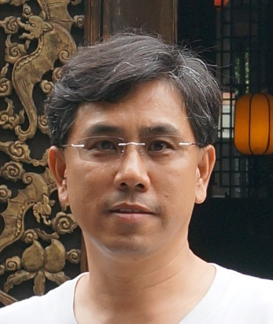
Shean-Jen Chen, Ph.D. received his B.S. degree from National Taiwan University in 1987 and his M.S. degree in Mechanical Engineering from Columbia University in 1991. In December 1996, he was awarded his Ph.D. degree for research in adaptive noise cancellation and image restoration at University of California, Los Angeles (UCLA). He entered Synchrotron Radiation Research Center of Taiwan in January 1998 where he became involved in the development of soft x-ray active gratings and microfocusing optical systems. He was an Assistant Professor at National Central University of Taiwan from August 2000 to July 2003, and a Distinguished Professor at NCKU from August 2012 to July 2016. He is a Professor and the Dean at College of Photonics, National Chiao Tung University, Taiwan from August 2018. Currently, he is actively engaged in researching advanced nonlinear optical microscopy and three-dimensional photolithography.

